First Name: __________________ Last Name: _______________________

PFFBSITO Gede Gaga Moon Cheese Beyonce Kittens with Flamethrowers

Density Pre - Test
Remember… no units = no credit.

1.) Circle the correct density Equation?

- Density = Weight divided by Mass
- Density = Mass divided by Volume
- Density = Volume divided Mass
- Density = Mass plus Volume
- Density = Mass times Volume

2.) What is the density of a rock that has a mass of 5 grams and takes up 5 cm3?

3.) What is the density of 50 ml of a liquid that weighs 100 grams?

4.) What is the density of a cube that is 1 cm high, 1 cm wide and 10 cm long and has a mass of 20 grams.

5.) What is the density of a Little Timmy if he weighs 100 grams
and has a take up 100,000 cm3

6.) Circle the image which of these represents the LEAST dense?

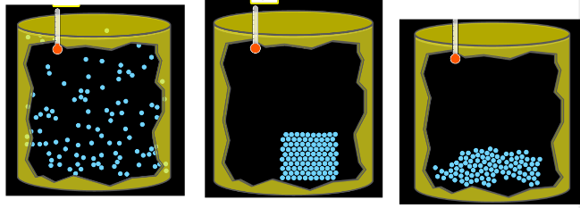

7.) Circle the image which of these represents the MOST dense?

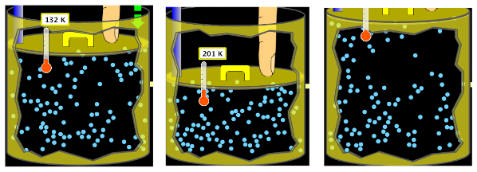

8.) Draw circles (about the size of this O) to make two images… put a smiley face in the box that has the LOWEST density.

9.) Draw two shapes and put a smiley face by the one with the SMALLEST Volume.

10.) A liquid has a density of 3.0 g/ cm3. Little Timmy has a box that weighs 1,000 grams and takes up 300 cm3. Find the density and predict if the box will sink or float in the liquid.

Answers for Density Pre – Test

1 B
2 1 g/cm3
3 2 g/ml (or 2 g/cm3 they are the same unit)
4 2 g/cm3
5 The density of Little Timmy is 0.001 g/cm3
6 The first box is the least dense.
7 The middle box is the most dense
8 Answers may vary. The smiley face goes in the box with the fewest particles.
9 Answers may vary. The smiley face goes in the box with the smallest size shape.
10 Density = 3.33 g/cm3 and the box will sink because the density of the box is greater than the liquid

